Sales Data Analysis and Business Insights
Data Science Final Project Report
Prepared by: Afan Ahmed Memon
Date: 18 October 2026
Tools: Python, Pandas, NumPy, Matplotlib, Seaborn, Streamlit

Problem Statement
Businesses record thousands of sales transactions, but raw records alone do not show which products, categories and regions drive revenue and profit, where discounting erodes margin, or how demand changes over time. Without a structured analysis, decisions on pricing, inventory and marketing rely on intuition. This project turns raw sales data into clean, reliable KPIs, visual analysis and an interactive dashboard so that decision-makers can find trends, top performers and problem areas quickly.

Introduction
The project is an end-to-end data science workflow: loading a real-world retail sales dataset, cleaning it, exploring it statistically and visually, calculating business KPIs, and presenting the findings in a Streamlit dashboard. The pipeline adapts to the columns available in the dataset, so optional analyses (time trends, customer segmentation) run only when the required fields exist.

3. Objectives
- Load and clean the sales dataset, handling missing values, duplicates and invalid records.
- Perform exploratory data analysis and compute summary statistics and KPIs.
- Analyse sales and profit by product, category, region and (where available) time period.
- Identify top-performing products and loss-making areas, and the effect of discounts.
- Present results through charts and an interactive, filterable dashboard.

Dataset and Methodology
Dataset: superstore.csv - 9,994 raw records, 13 columns (ship_mode, segment, country, city, state, postal_code, region, category, sub_category, sales, quantity, discount, profit).

Data cleaning summary
Step | Result
Raw records | 9,994
Duplicate rows removed | 17
Rows dropped (missing date/sales) | 0
Outlier records flagged (IQR, kept) | 1,167
Clean records used for analysis | 9,977

Method
- Cleaning: standardised column names, removed duplicates, converted data types, dropped rows missing critical fields, filled other gaps (median for numbers, 'Unknown' for text), removed invalid values, flagged outliers with the IQR rule.
- Feature engineering: year, month, quarter, weekday and profit margin where the data allows.
- KPIs: total sales, profit, profit margin, orders, average order value, growth.
- Analysis: group summaries, discount impact, correlation, distributions, and RFM customer segmentation when customer IDs and dates exist.
- Dashboard: Streamlit app with filters, KPI cards, tabbed charts and CSV download. Note: this dataset has no order-date column, so time-trend analysis is not included.

App UI Screenshots
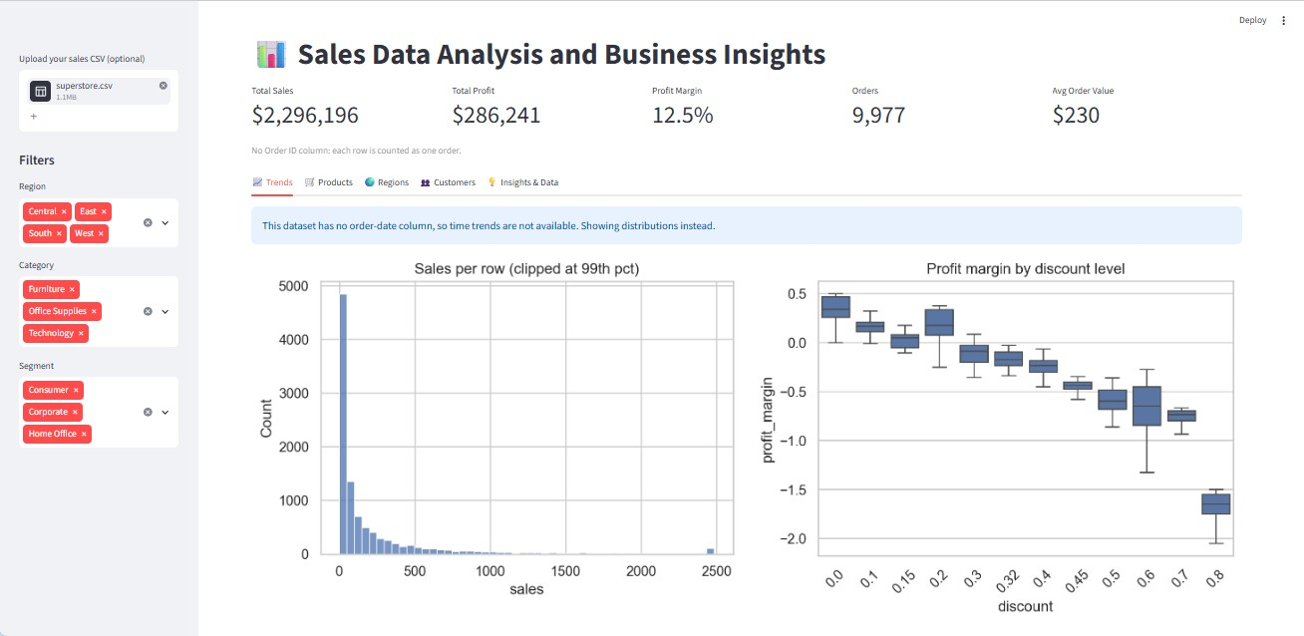
Figure: 1
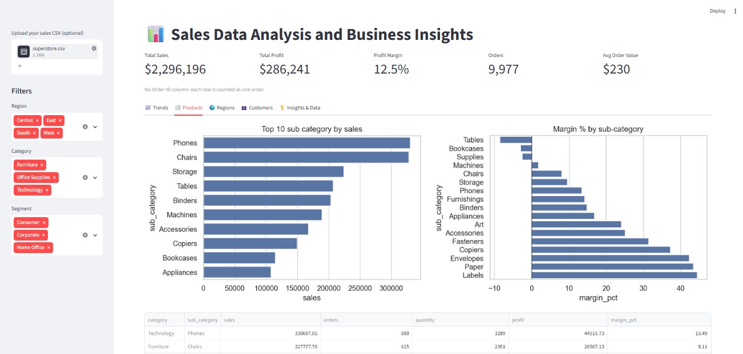
Figure: 2 (1)
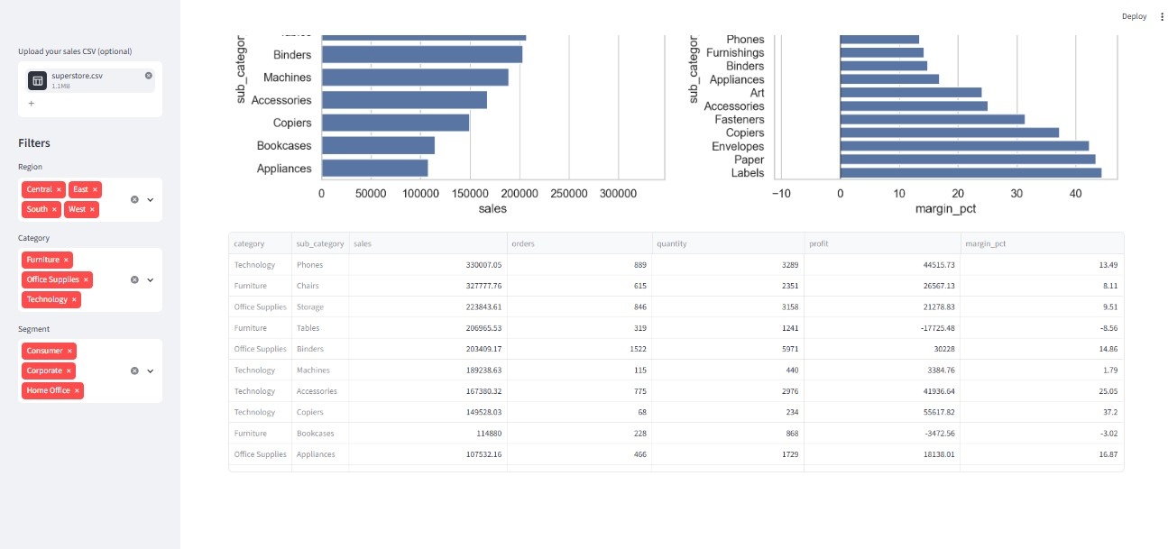
Figure: 2 (2)
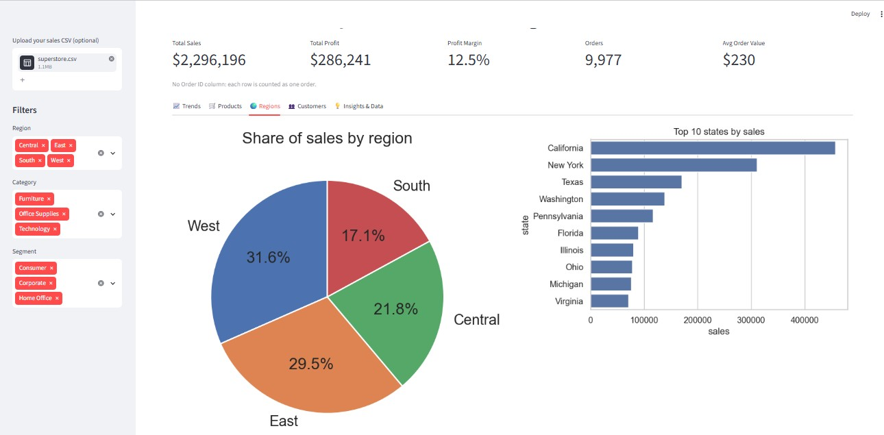
Figure: 3 (1)
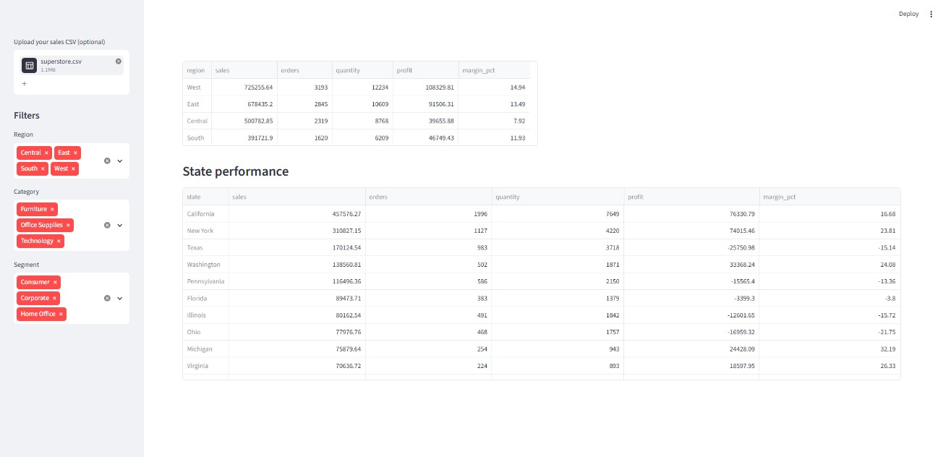
Figure: 3 (2)
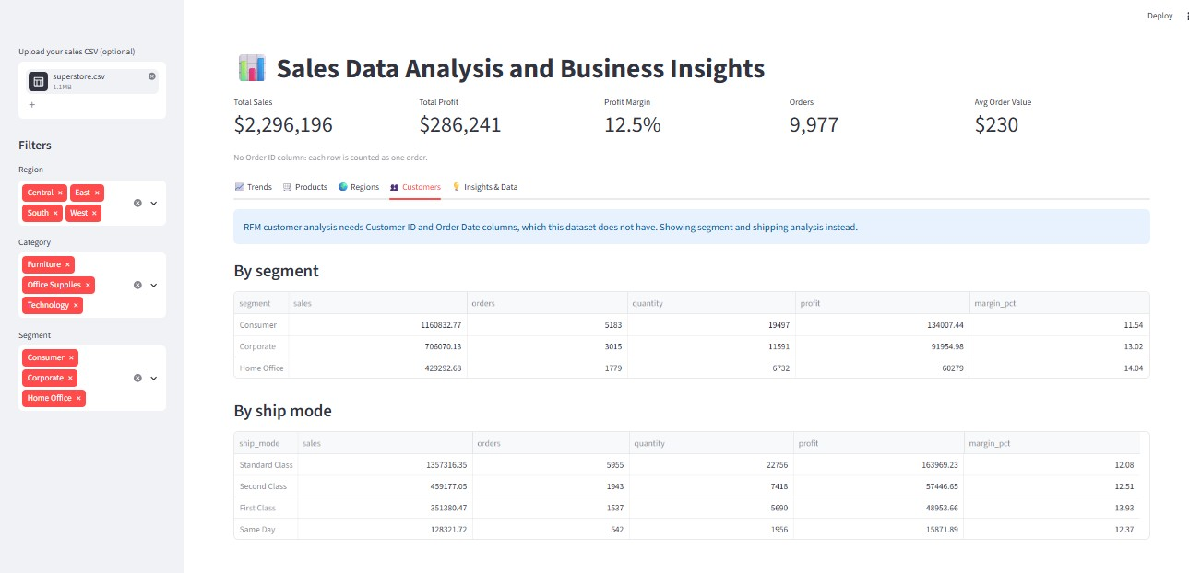
Figure: 4
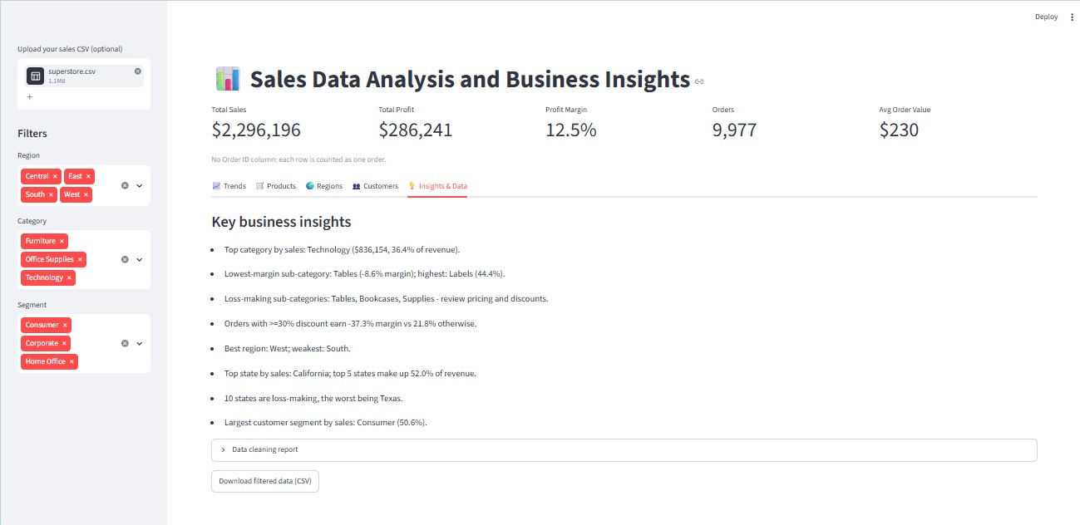
Figure: 5

Results

Key performance indicators
KPI | Value
Total sales | $2,296,196
Orders / records | 9,977
Average order value | $230.15
Units sold | 37,820
Total profit | $286,241
Profit margin | 12.5%

Key business insights
- Top category by sales: Technology ($836,154, 36.4% of revenue).
- Lowest-margin sub-category: Tables (-8.6% margin); highest: Labels (44.4%).
- Loss-making sub-categories: Tables, Bookcases, Supplies - review pricing and discounts.
- Orders with >=30% discount earn -37.3% margin vs 21.8% otherwise.
- Best region: West; weakest: South.
- Top state by sales: California; top 5 states make up 52.0% of revenue.
- 10 states are loss-making, the worst being Texas.
- Largest customer segment by sales: Consumer (50.6%).

Performance by category
Category | Sales ($) | Profit ($) | Margin (%) | Records
Technology | 836,154 | 145,455 | 17.4 | 1,847
Furniture | 741,306 | 18,422 | 2.5 | 2,118
Office Supplies | 718,735 | 122,365 | 17.0 | 6,012

Performance by region:

Region | Sales ($) | Profit ($) | Margin (%) | Records
West | 725,256 | 108,330 | 14.9 | 3,193
East | 678,435 | 91,506 | 13.5 | 2,845
Central | 500,783 | 39,656 | 7.9 | 2,319
South | 391,722 | 46,749 | 11.9 | 1,620

Performance by sub category:

Sub Category | Sales ($) | Profit ($) | Margin (%) | Records
Phones | 330,007 | 44,516 | 13.5 | 889
Chairs | 327,778 | 26,567 | 8.1 | 615
Storage | 223,844 | 21,279 | 9.5 | 846
Tables | 206,966 | -17,725 | -8.6 | 319
Binders | 203,409 | 30,228 | 14.9 | 1,522
Machines | 189,239 | 3,385 | 1.8 | 115
Accessories | 167,380 | 41,937 | 25.1 | 775
Copiers | 149,528 | 55,618 | 37.2 | 68
Bookcases | 114,880 | -3,473 | -3.0 | 228
Appliances | 107,532 | 18,138 | 16.9 | 466

Visual analysis
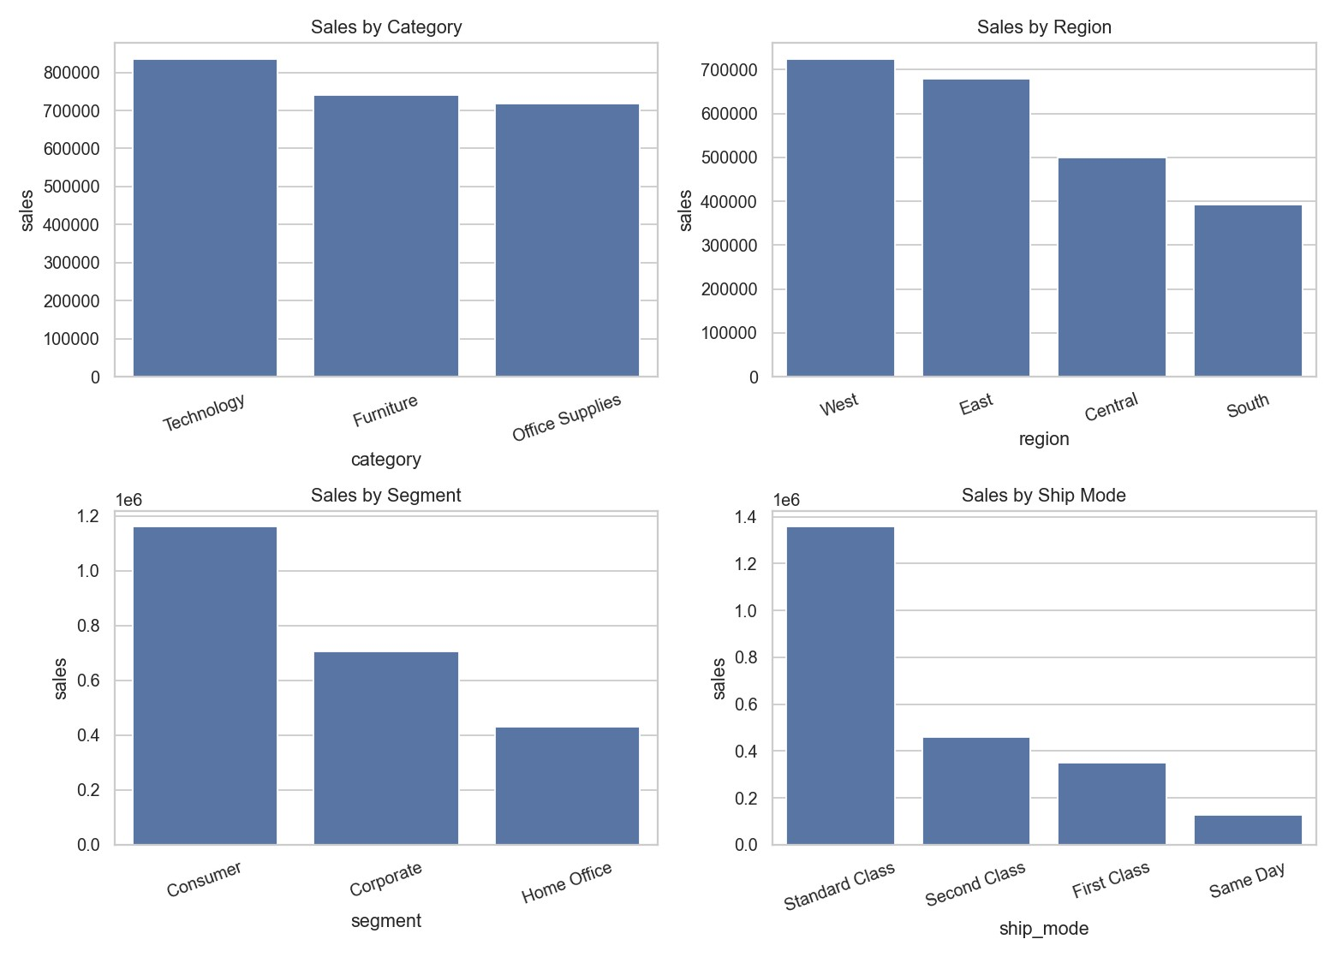
Sales by category, region, segment and shipping mode.
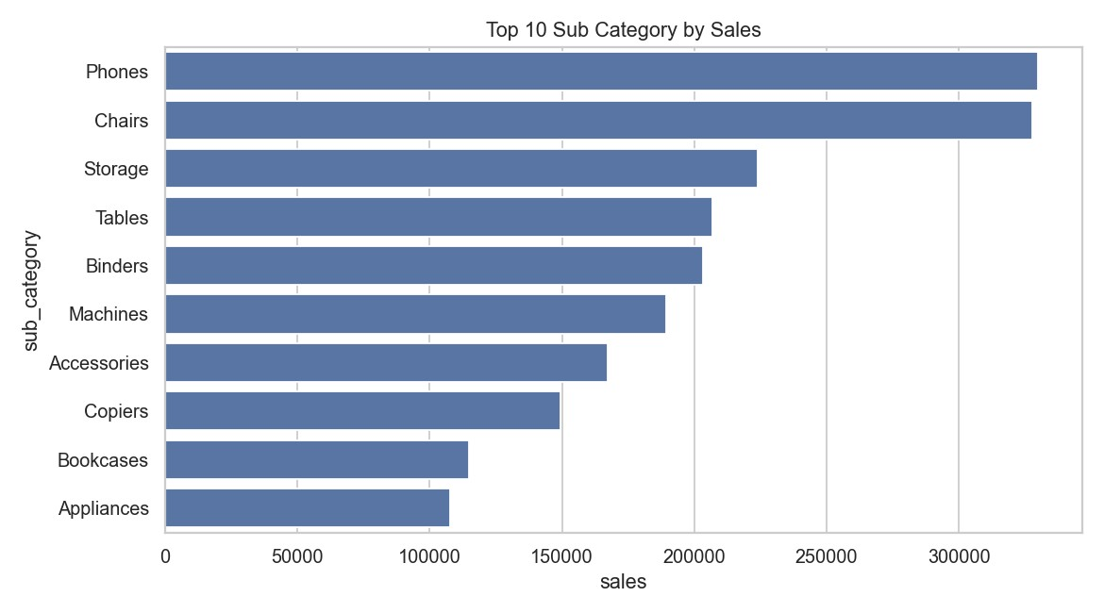
Top 10 products / sub-categories by sales.
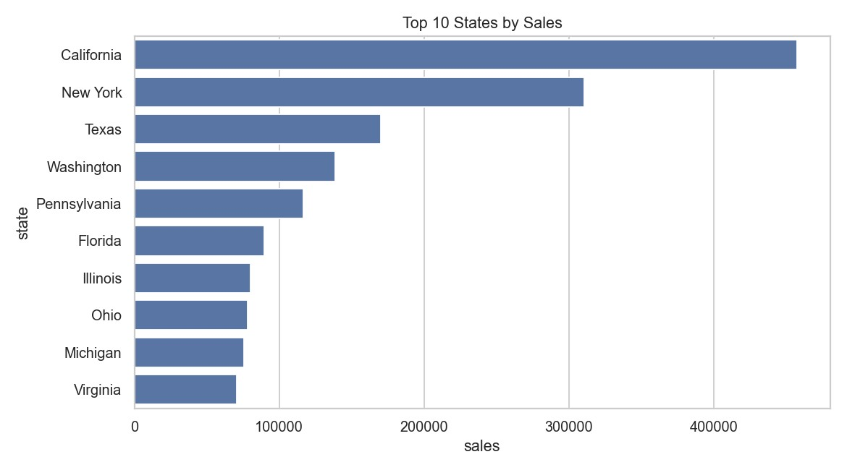
Top 10 states by sales.
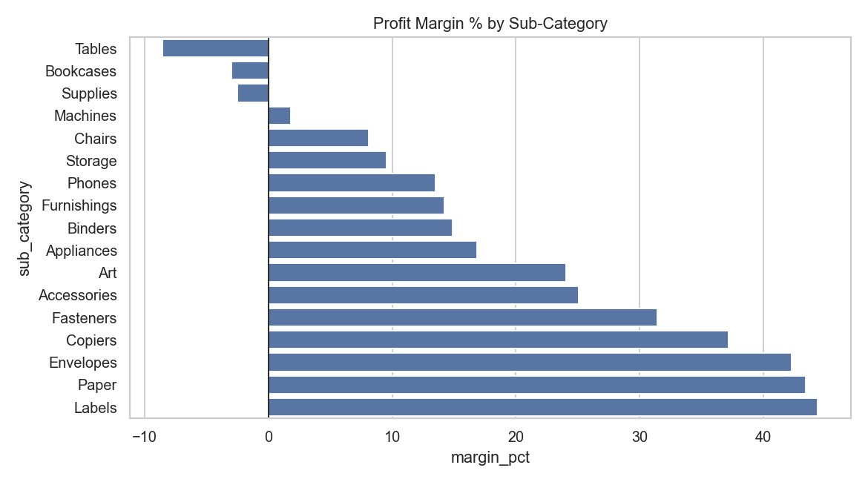
Profit margin (%) by sub-category.
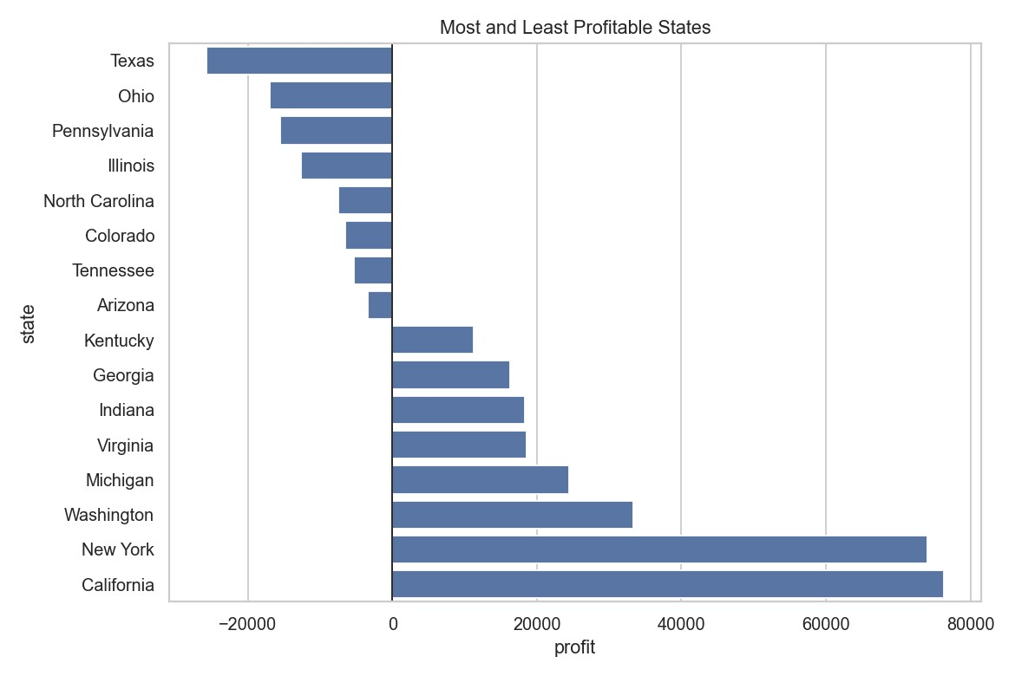
Most and least profitable states.
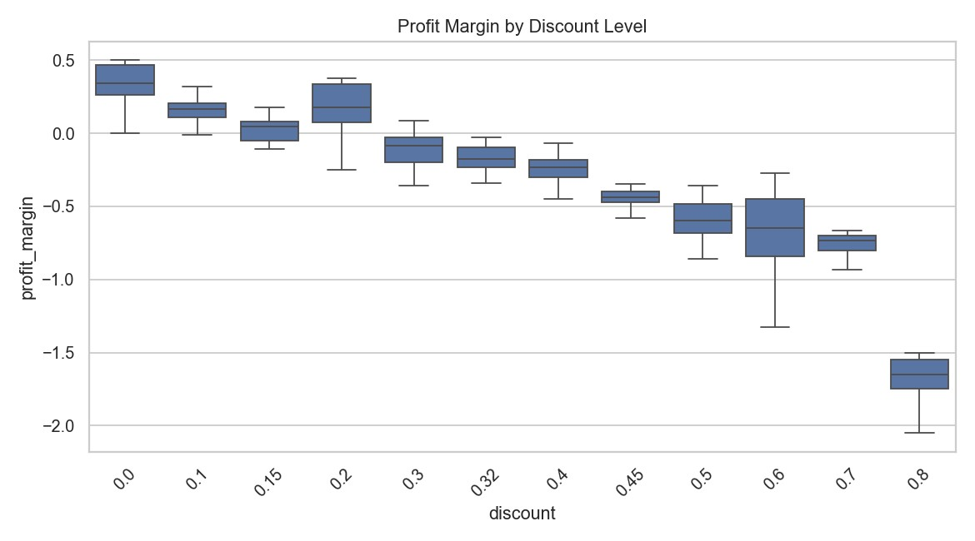
Profit margin by discount level.
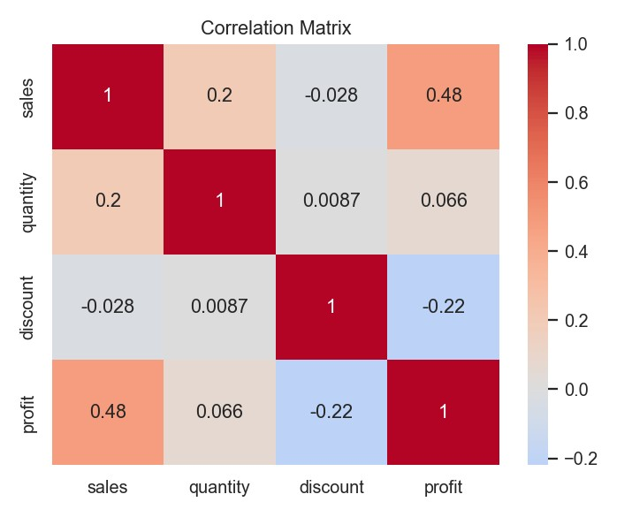
Correlation between numeric variables.
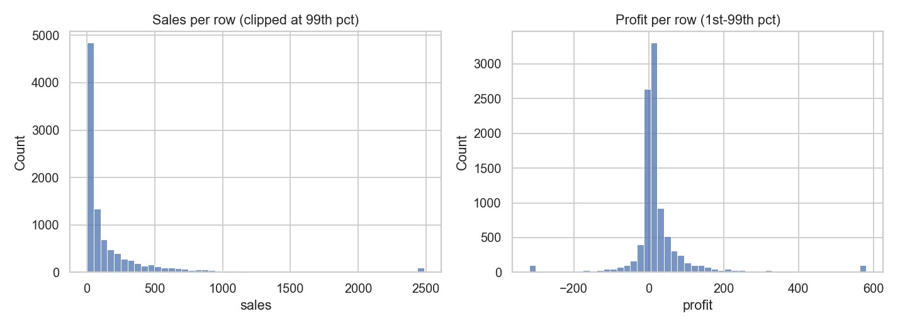
Distribution of sales and profit per record.

Conclusion
The project shows how a systematic cleaning and analysis pipeline converts raw sales records into decisions: it highlights the strongest categories and regions, exposes loss-making segments, and quantifies how heavy discounting affects profit margin. The dashboard lets non-technical users filter and explore these results on their own.

Future Approach
- Sales forecasting: add time-series models (ARIMA / Prophet) to predict future demand when date data is available.
- Profit prediction and discount optimisation: train regression or gradient-boosting models to find discount levels that protect margin.
- Customer analytics: extend RFM into customer lifetime value, churn prediction and product recommendations using customer-level data.
- Richer interactivity: move charts to Plotly for hover, zoom and drill-down.
- Live data pipeline: connect the dashboard to a database or API instead of a static CSV, with scheduled refresh.
- Quality and operations: add automated tests, CI checks, authentication and automated report emails.

